Finite Element Analysis of the Crane:

The analysis is performed by using a 2D truss code that was written according to the instructions for the first practical of the course iFEM. For the material properties, the specified values in the project description were filled into MatLab. Together with defining the nodes and the elements, the script was able to run successfully, and the deformation of the crane defined as in the problem description were found. These values can be found in the table below. The stress values were also checked to make sure they do not exceed the yield strength, which means there is no plastic deformation in our crane.

The second step of the analysis was to check whether it was possible to remove a truss element from the crane. The only elements that could possibly be removed after a brief analysis were thought to be element 12 and 13. By attempting to remove one of these elements and running the code again it was found that the only possibility is that element 13 can be removed and not element 12. The deformation of removing element 13 still stayed below the specified 4 mm and thus it can be removed safely. The stresses also will not exceed the yield strength if this element was removed. The results of the Finite element analysis are shown in the table below.

|  | **Possible crane setup** | | |
| --- | --- | --- | --- |
| **Properties** | Complete crane | Removing element 12 | Removing element 13 |
| Deformation at the tip [mm] (x-direction) | -2.00 | -36.56 | -2.00 |
| Deformation at the tip [mm] (y-direction) | -225.63 | -3.58e+16 | -225.63 |
| Highest occurring Stress [MPa] | 232.92 | 218.54 | 232.92 |

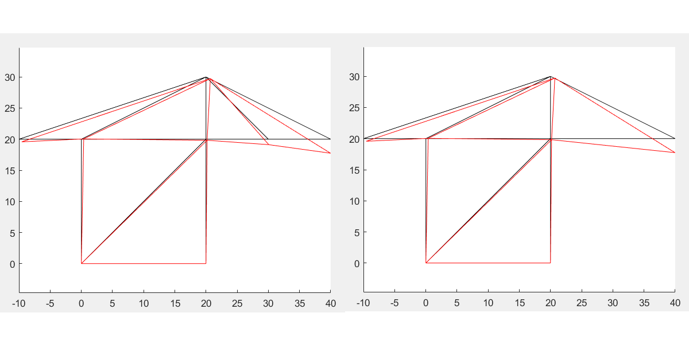

Figure ‘’: The complete crane assembly and the crane assembly without

element 13. The black lines show the undeformed structure and the red lines show the deformed structure. Both the x-axis and y-axis are in meters.